
 Nitte Meenakshi Institute of Technology
(AN AUTONOMOUS INSTITUTION AFFILIATED TO VISVESVARAYA TECHNOLOGICAL UNIVERSITY, BELGAUM)
PB No. 6429, Yelahanka, Bangalore 560-064, Karnataka
Telephone: 080- 22167800, 22167860
Fax: 080 – 22167805


Department of Information Science and Engineering
2023-2024

DBMS MINI PROJECT (FINAL REPORT)
on

Football Management System

Submitted in partial fulfilment of the requirement for the award of Degree of
Bachelor of Engineering
in

Information Science and Engineering
Submitted by:

M SUHAS 1NT21IS084
M KEERTHI 1NT21IS086
P KOUSHIK 1NT21IS109


 Nitte Meenakshi Institute of Technology
(AN AUTONOMOUS INSTITUTION AFFILIATED TO VISVESVARAYA TECHNOLOGICAL UNIVERSITY, BELGAUM)
PB No. 6429, Yelahanka, Bangalore 560-064, Karnataka
Telephone: 080- 22167800, 22167860
Fax: 080 – 22167805

DEPARTMENT OF INFORMATION SCIENCE AND ENGINEERING

CERTIFICATE

This is to certify that the Course Project titled “FOOTBALL MANAGEMENT SYSTEM” is an authentic work carried out by M SUHAS(1NT21IS084) M KEERTHI(1NT21IS086) P KOUSHIK(1NT21IS109) bonafide students of Nitte Meenakshi Institute of Technology, Bangalore in partial fulfilment for the award of the degree of Bachelor of Engineering in INFORMATION SCIENCE AND ENGINEERING of Visvesvaraya Technological University, Belagavi during the academic year 2023-2024.

Signature of the Faculty In charge Name and Signature of the
HOD
(Priyanka K)
Dr. Mohan S G

ABSTRACT
A Football management system is a software application where it is designed to manage the data of every day of the tournament. It includes to stores the data of player, game, venue,manager..etc.

The main goal of a football management system is to provide an efficient and effective way to manage the various aspects of football functions, including no. of goals, country, and ids. This includes the ability to catalogue and classify records, track the no of goals and no. of matches won.

And also to these core functions, a football management system may also provide additional features such as the ability to edit for and delete details online, generate reports and statistics, and integrate with other systems such as online databases and record collections.

Overall, a football management system plays a vital role in the smooth operation of a everything, helping to streamline processes and improve the user experience.

ER DIAGRAM

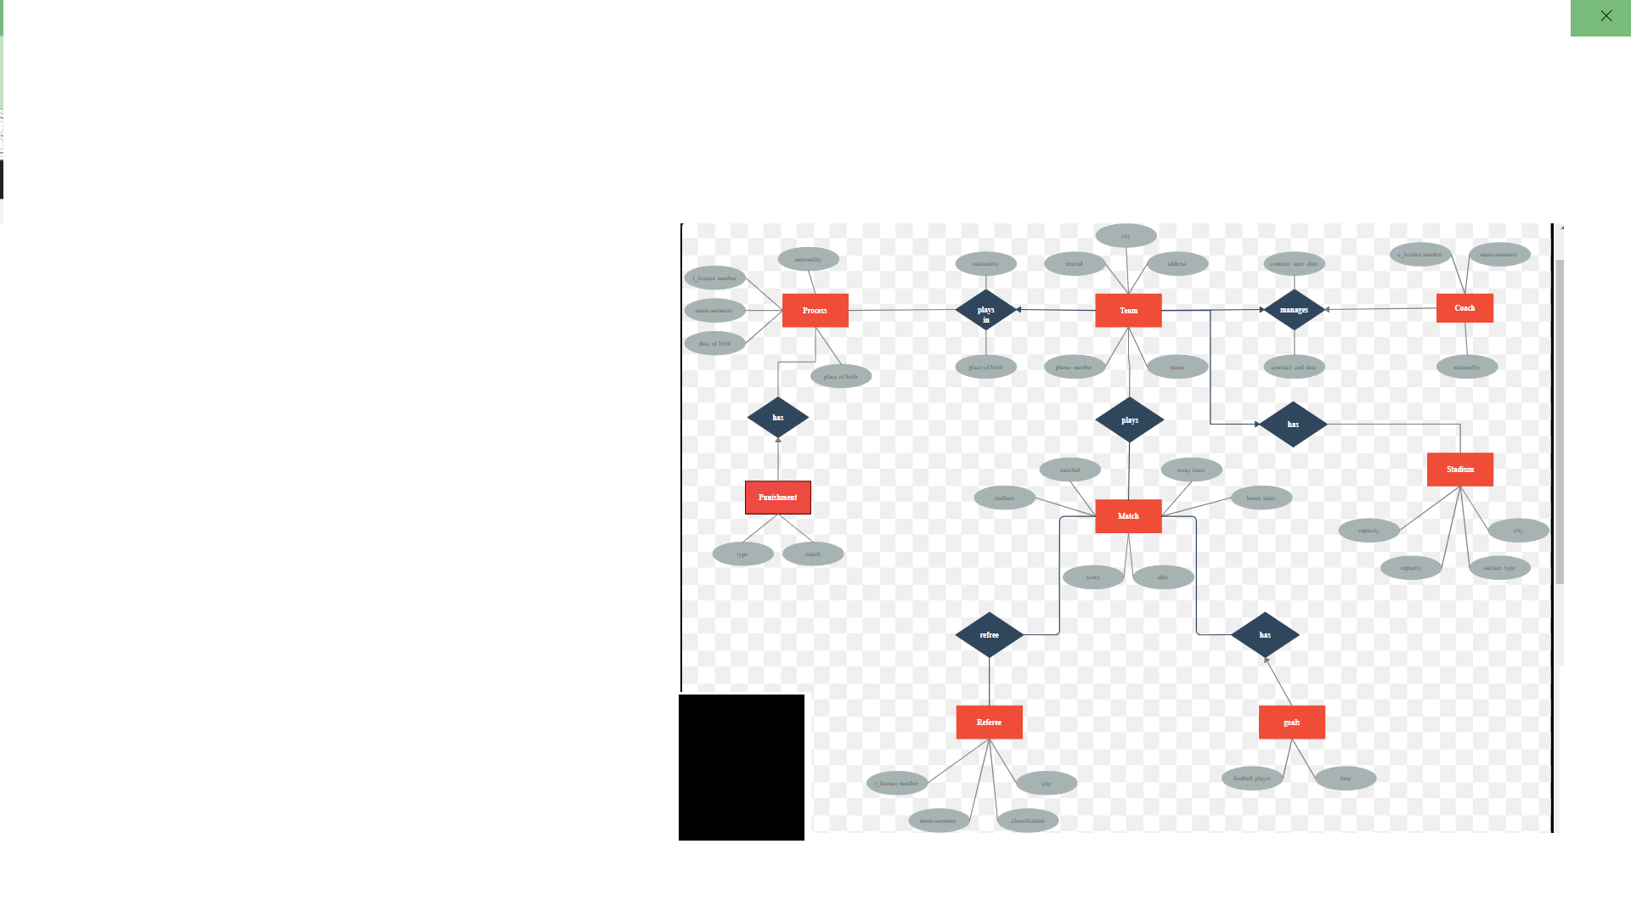

SCHEMA DIAGRAM

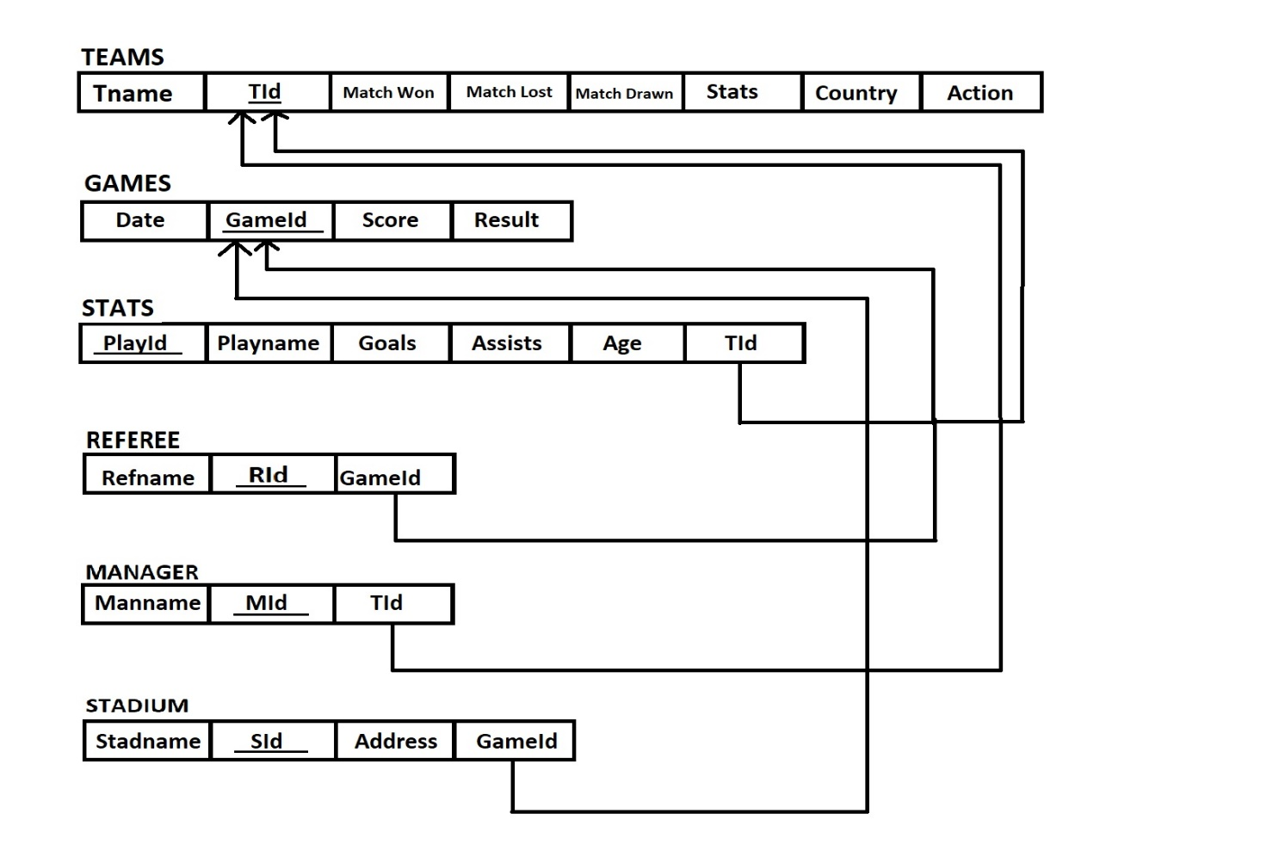

IMPLEMENTATION

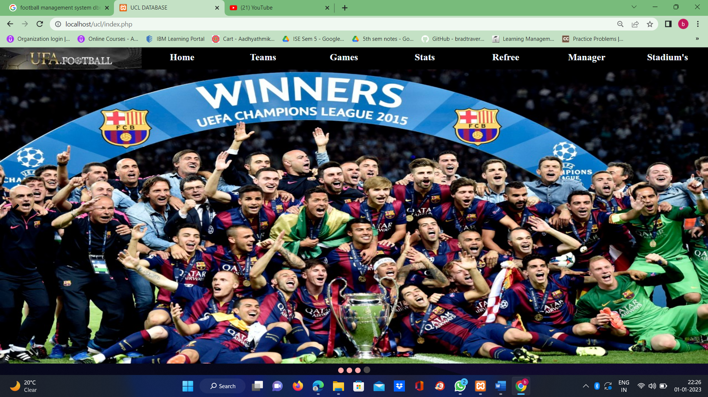

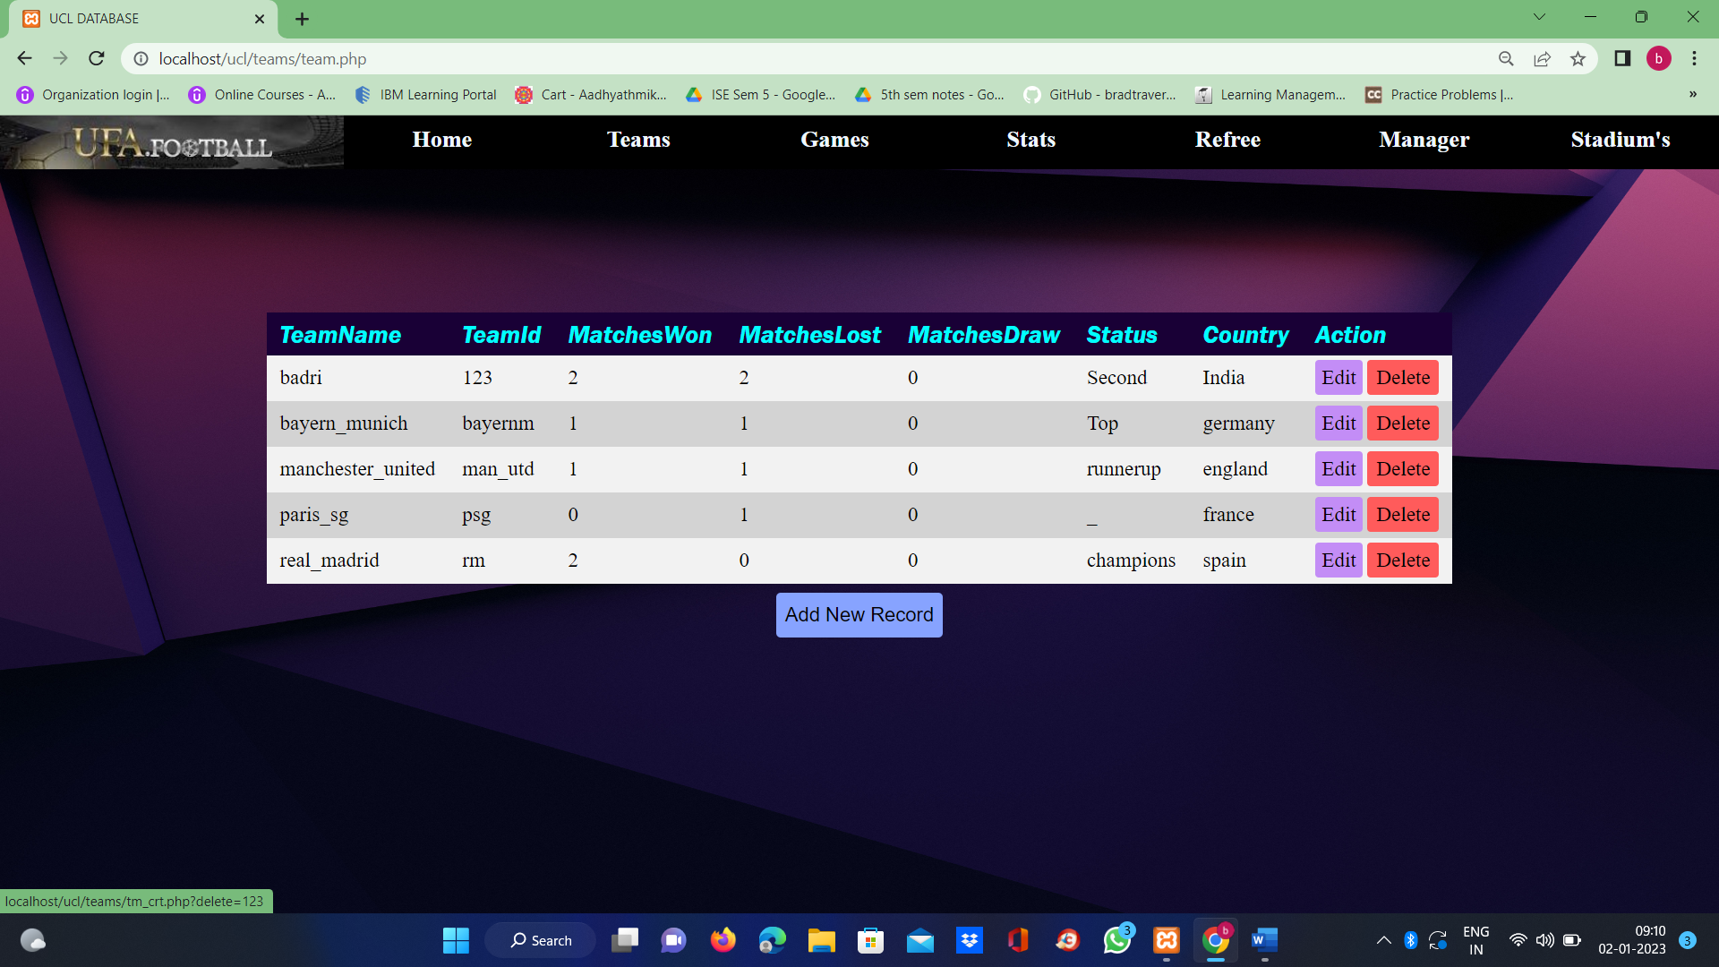

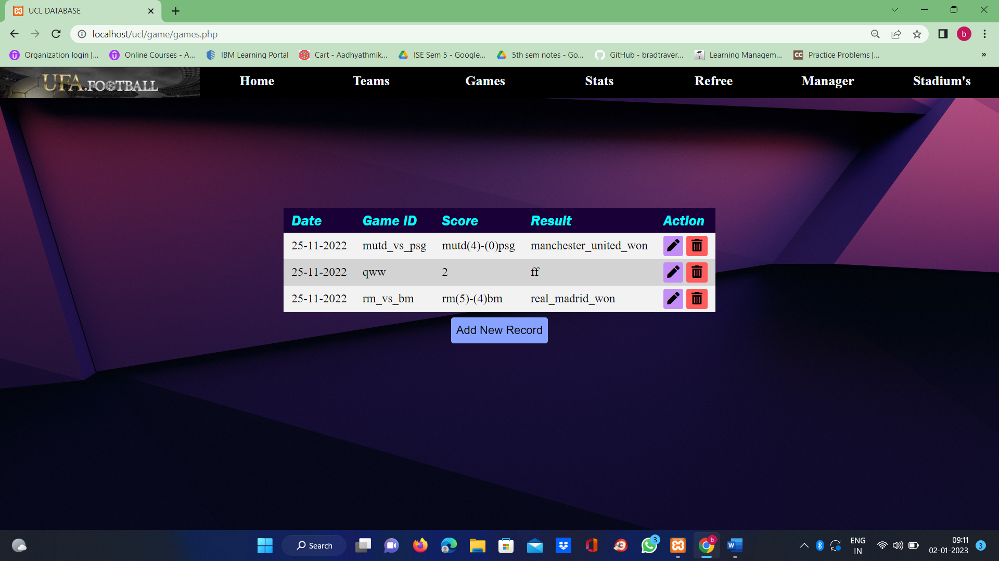

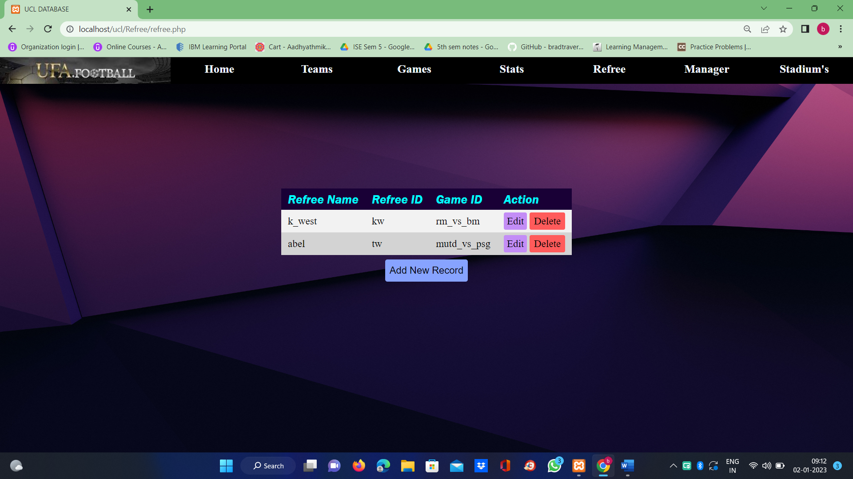

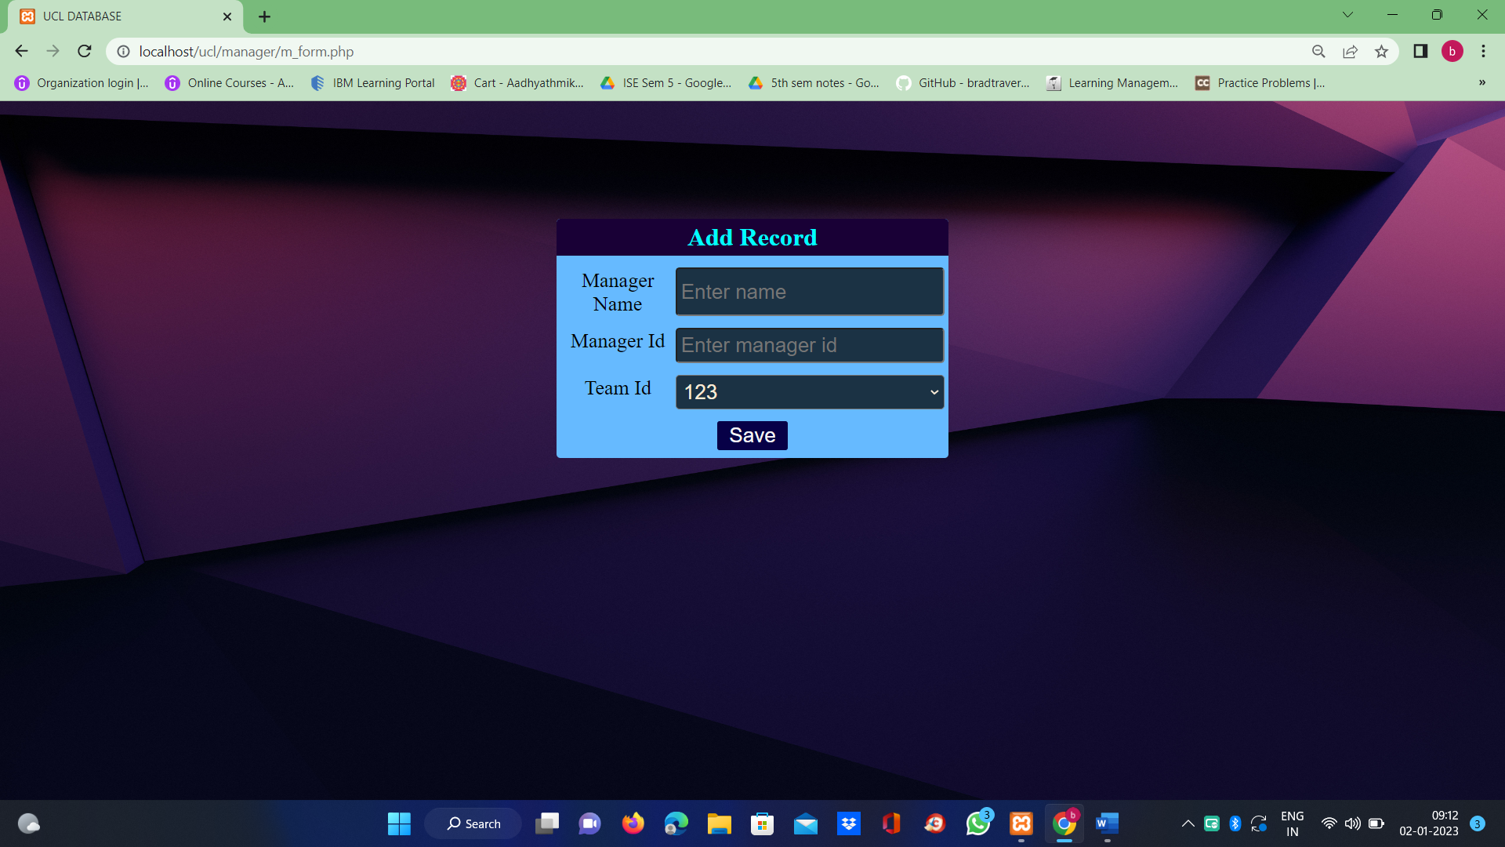

Conclusion
A football management system is a software application that helps to keep records and to manage their goals, matches, and handle other all other operations. It can be used to manage all types of football records like referee, stadiums, no of matches played..etc.
There are several benefits of using a football management system. It can help football records to save time and money by automating tasks such as saving and editing the records. It can also make it easier for all types of people to access the records and can know the details, as they can see all the updated data and if required, we can delete and edit the data. Additionally, a football management system can help games to keep track of their updated list and ensure that they are properly maintained and preserved.
Overall, a football management system can be a useful tool for improving the efficiency and effectiveness of a football records, and it can help to enhance the user experience.

References
https://soccersystempro.com/
https://www.youtube.com/watch?v=h_wQDR9P

